Manual Book for Grade Predictor

1. **Login**

To get access to this system, make sure you can login with Pitt Passport and your role is advisor. If you have any questions, please contact the Pitt IT.

1. **Upload Current Student Data**

The database of the system may not be updated. If you want to use the system for current students who are not in our database. Please upload a .csv file before using. A example format of the .csv file is:

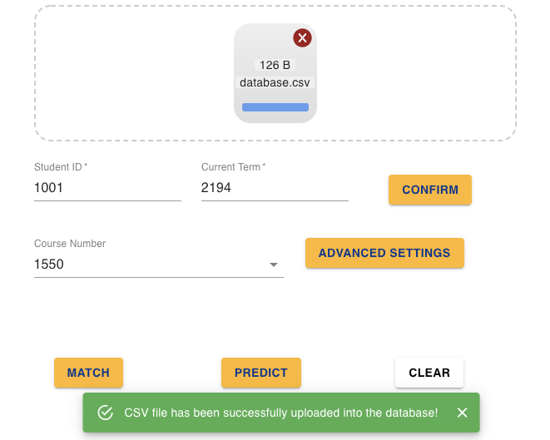

<Header>

Analytics ID, Student Full Name, Academic Term Code, Catalog Number, Final Grade Code

<Format>

7-digit number, "LastName, FirstName", 4-digit number, up to 4-digit number, [A+, A, A-,...] (which may include non-GPA grades like W)

Example:

1234567, Student Name, 2201, 447, B

1234567, Student Name, 2201, 447, B

1234567, Student Name, 2201, 447, B

1. **Necessary Input**

After login, the necessary input is student id and current term. After filling these two fields, you need to press the Confirm button to get the course list. Then you must select one course to do the matching and prediction.

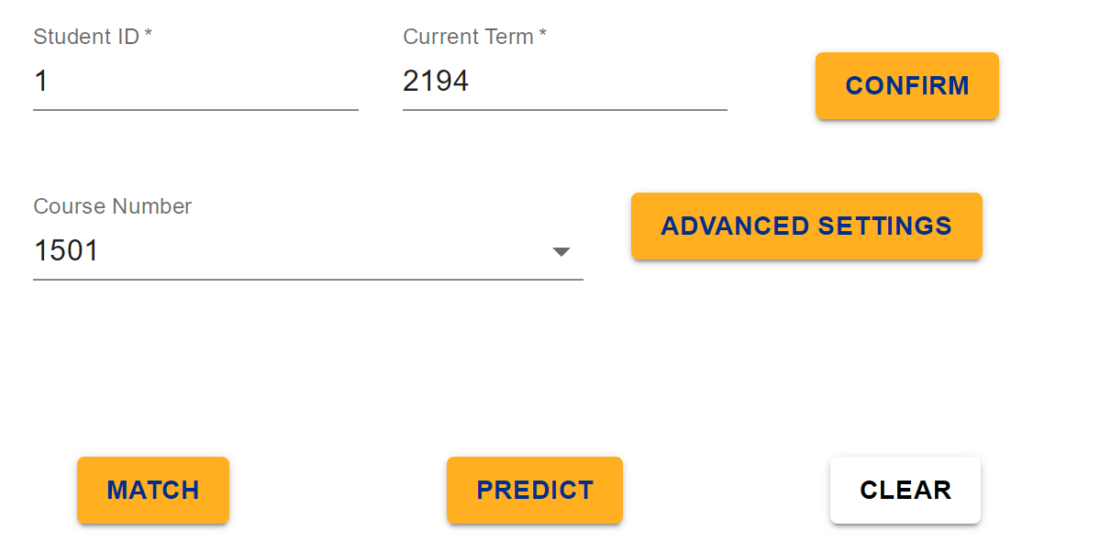

1. **Advanced Setting**

Some input parameters have been initialized with some default values. You can always change these parameters by clicking **Advanced Settings**, then use some sliders or dropdowns to customize your input.

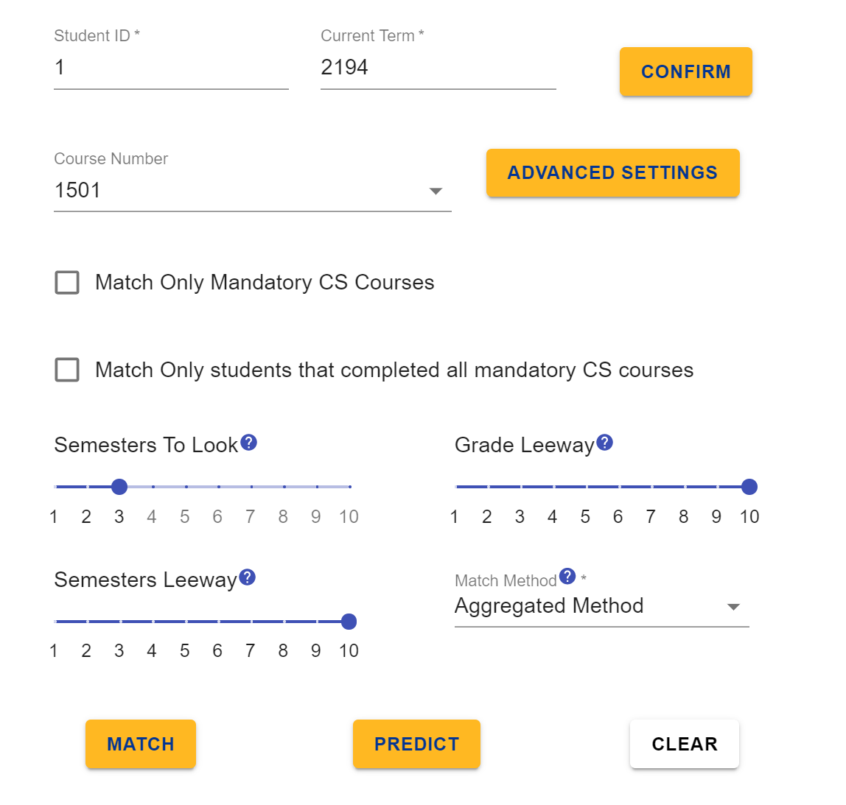

1. **Grade Matching**

The **Match** button is the entry to show historical results that matched with your input. By default it is the aggregated result, which is generated by averaging three results (database matching, machine learning method 1, and machine learning method 2). If you want to see any one of these methods.

You can also click show percentage switch to switch between result in percentage format and real counts format.

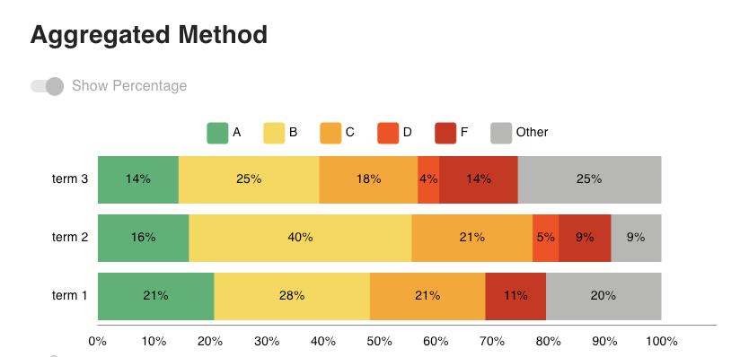

1. **Grade Predicting and Study Path Recommendation**

You can also click the **Predict** button to predict the grade distribution for a specific course in the current term selected by a given student. So the first bar chart will show the probability distribution for each grade. Then we also provide a study path recommendation for the advisor to reference. The first table will show some courses recommended to take before taking the target course, ranked by the chance to get an A. The second table shows some top frequent courses in study path recommendation that can help the student to get an A.

